**A DIGITAL HEARING AID**

Ankur Agarwal(Y09UC216)

Hansraj Gujar(Y09UC233)

NeerajGupta(Y09UC254) ShreyUpadhyay(Y09UC282)

Sumit Gautam(Y09UC285)

LNMIIT , Jaipur

-------------------------------------------------------------------------------------------------------------------------------  
**Aim**

To develop noise reduction, frequency, and amplitude filters for a configurable digital hearing aid (DHA).

**Tools And Commands Used**

1. WDENCMP -WDENCMP performs a de-noising or compression process of a signal or an image using wavelets.

[XC,CXC,LXC,PERF0,PERFL2] = WDENCMP('gbl',X,'wname',N,THR,SORH,KEEPAPP)

It returns a de-noised or compressed version XC of input signal X (1-D or 2-D) obtained by wavelet coefficients thresholding using global positive threshold THR.

2. DDENCMP- DDENCMP Default values for de-noising or compression.

[THR,SORH,KEEPAPP] = DDENCMP(IN1,'wv',X)

It returns default values for de-noising or compression, using wavelets or wavelet packets, of an input vector or matrix X which can be a 1-D or 2-D signal. Where THR is the threshold, SORH is for soft or hard thresholding, KEEPAPP allows you to keep approximation coefficients.

**Procedure**

* For Noise Reduction- Instead of adding white noise to a speech signal, we were able to obtain and generate several .wav sound files of a main speech signal with various sources of white noise in the background.We experimented with implementing an FIR filter, but after researching various pre-existing MATLAB commands, we used the command wdencmp,which performs noise reduction/compression using wavelets. It returns a de-noised version of the input signal using wavelet coefficients threshholding. We also utilized the MATLAB command ddencmp.
* For Frequency Shaper-The filter applies a gain greater than one to the frequencies that the user has difficulty hearing. As one of its parameters, the filter takes in a vector of frequencies(transitionV), that define the user's hearing characteristics. For each range, the frequency shaper applies a certain gain based on the user's specific hearing loss. Thus, our frequency shaper iscompletely configurable to any user.
* For Amplitude Shaper-We assume that the Frequency Shaper raises the frequencies that the user has difficulty hearing to sound pressure levels within his dynamic range of hearing. Therefore, all that our Amplitude Shaper has to do is check, bit by bit, that output power does not exceed a given saturation level, Psat. Since noise is concentrated in the low power levels as well, the filter also removes a significant amount of noise. Output power is equal to zero for levels below Psat.

**Design Details**

**Assumptions:**

* A Threshold of Hearing at 40 dB
* A Threshold of Pain at 110 dB
* A saturation level (Psat) of 90 dB (where sounds begin to become uncomfortable)
* Difficulty to hear high frequencies

We used the concatenation of piecewise functions that change at f = 3000,4000,5000,and 9000 in hertz.

**Basic designs**

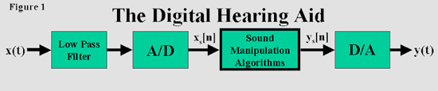

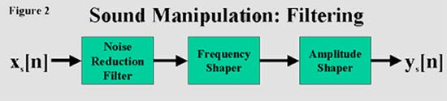

**Observations-**

1.Frequency shaper transfer function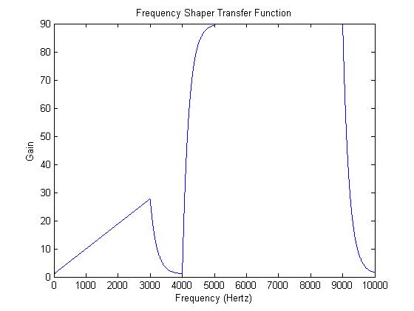

Signal Before and after hearing aid

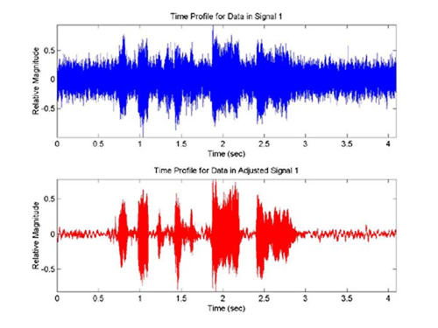

Power characteristics

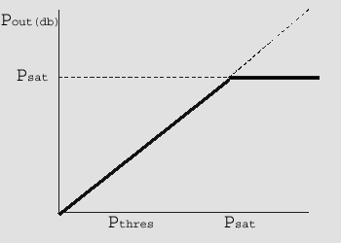

Spectrogram of original and adjusted signal

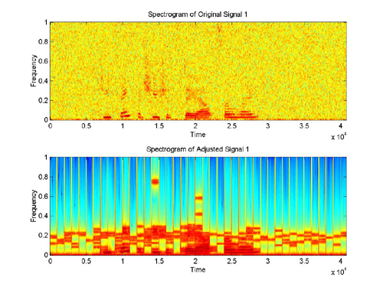

**Conclusion**

* Comparing the graphs of the original signal and the filtered signal, we saw that the amplitude of the noise in the signal was noticeably reduced.
* We also compared the spectrograms of the two signals and saw that the speech signal was stronger and more recognizable.
* We can use these filters in telecommunication systems such as satellites and cell phones, in image processing, or in any place where there is sensitivity to high frequencies or loud noises.